LP#77 Upper La Puerta Avenue,
Diego Martin
June 7th, 2014

Dear Sir/Madam,

I wish to apply for the vacant position of Game room attendant, Front counter staff or Cashier in your organization.

I am a diligent, honest and responsible worker and I perform best in an environment that fosters team effort.

Please find attached copies of my Resume and Application Letter.

I may be contacted at 331-7803. I stand ready to furnish any further information you may require and hold myself available to attend an interview at a date convenient to you.

Thanking you in advance for your kind consideration.

Yours respectfully,

…………………………
Deborah St John

Resume

Deborah St John
Lp# 77 Upper La Puerta Avenue, Diego Martin
331-7803
22.07.1988

Objective: To obtain a position where I can utilize my skills and gain more experience, which will leave an open door for me to journey through and strive towards my career of choice.

Educational Background: 1993-2000- La Puerta Government Primary School
2000-2003- Diego Martin Junior Secondary School
2003-2005- Bishop’s Centenary College
2006-2007- Continuation classes at South East Secondary
School

Summary of Qualifications: CXC O’Levels Obtained
English Language (Grade III)
Food and Nutrition (Grade III)
Computer Literacy

Summary of Work Experience: 2001 (Christmas Vacation) Glamour and Glitter as
Sales Clerk
2002 (August Vacation) Sparkling Gems Pre School
And Day Care as a Day Care Provider
2004- 2006 - Glamour and Glitter as a Sales Clerk
2007- 6months with the O.J.T Program at The
Ministry Of Housing as a Clerical Assistant/
Data Entry Clerk/
Receptionist
2008- February 18th – 29th Cashier at Hilo Food
Stores
2008- 2009- 6 months with the O.J.T Program at
The Ministry of Education as a Clerical
Assistant.
2010-2014- Dollar Giant as Cashier

Certificates: Cashier Training (Completed)
Attitudinal and Personal Development Workshop (Completed)

References: * Ms. Ingrid Craig
Upper La Puerta Avenue,
Diego Martin
Telephone No#: 796-9474

*Ms. Rachel Marshall
Lockhart Lane,
Belmont
Telephone No#: 752-5377



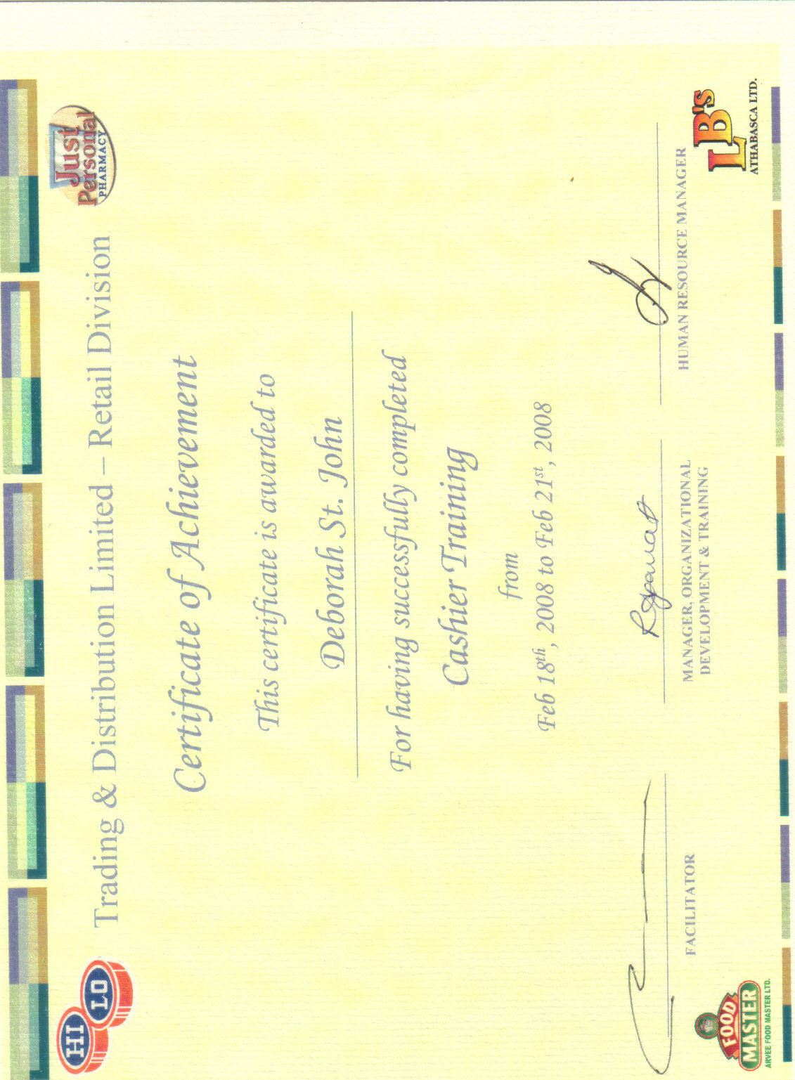
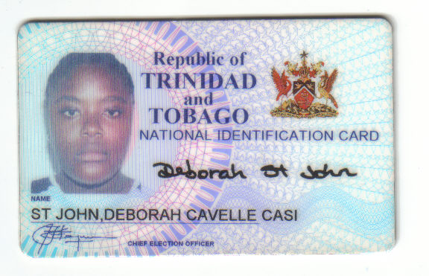

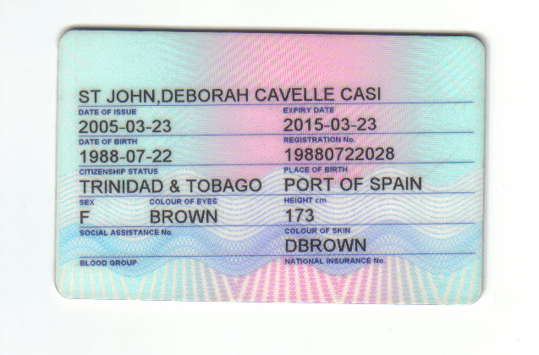

75c La Puerta Avenue,
Diego Martin.

May 12th, 2014

TO WHOM IT MAY CONCERN

Dear, Sir/ Madam

This letter serves to certify that I have known Ms. Deborah St John for the past eighteen (18) years. From the onset, she distinguished herself from others by her exceptional qualities and has proven herself to be an individual of character. She is very responsible and ambitious

For the time that I have known Deborah, she has also demonstrated high standards of discipline and work ethics.

I have no hesitation in recommending Ms. Deborah St John to you and I have every confidence that she will make a sterling contribution to your organization.

Sincerely,

______________________
Ingrid Craig

Lockhart Lane,
Belmont.

April 21st, 2014

TO WHOM IT MAY CONCERN

This serves to confirm that I have known the bearer Ms Deborah St John for the past twenty (20) years. During this time Ms. St John has displayed a wonderful disposition. She is a trustworthy, honest and hardworking person.

Ms. St John is quite a focused young lady who is pleasant and respectful and is always willing to go the extra mile for the benefit of a company.

I am quite impressed with Ms. St John’s determination and demeanor in her pursuits. I am confident that these traits would make her successful in any endeavor.

I wish to recommend her highly to any prospective employer.

Sincerely,

__________________________
Rachel Marshall

